The VA is undeterred on psychedelics
By ERIN SCHUMAKER, DANIEL PAYNE and RUTH READER

10/30/2024 02:00 PM EDT

THE LAB
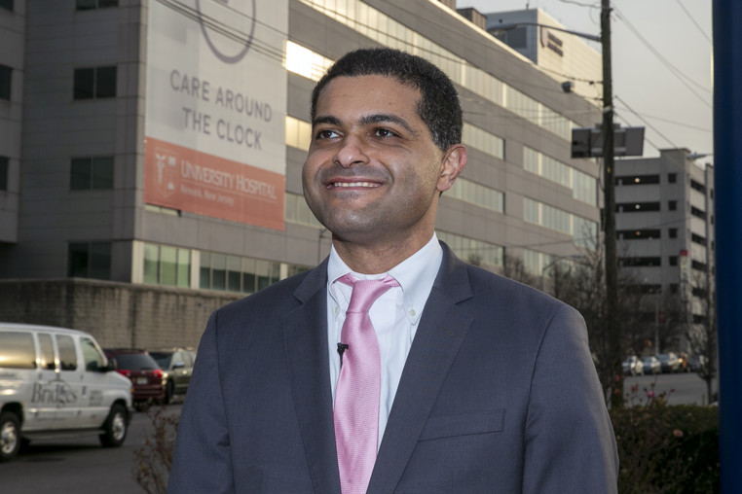
Elnahal is leading the push for research on psychedelics at the VA. | AP
The Department of Veterans Affairs remains convinced that psychedelic therapy can help treat veterans with post-traumatic stress disorder — and it’s going to try to prove it.
That commitment comes despite the FDA’s August rejection of a drug company’s plan to offer a psychedelic regimen for PTSD.
How so? The VA is funding a study on whether MDMA, also known as ecstasy, combined with talk therapy is an effective treatment for PTSD and alcohol-use disorder, Dr. Shereef Elnahal, the VA undersecretary for health, announced on LinkedIn.
“The U.S. Department of Veterans Affairs must lead on this encouraging area of investigation so that we can continue to build trust with Veterans contending with these severe health conditions,” he wrote, adding: “And we will.”
Researchers at Providence VA Medical Center in Rhode Island will lead the study.
Why it matters: The Food and Drug Administration rejected an MDMA and talk therapy treatment from Lykos Therapeutics after the agency’s outside advisers found the regimen wasn’t effective and the company hadn’t shown that its benefits outweighed its risks.
Lykos subsequently laid off 75 percent of its staff, and its top leaders left. The FDA told the company it would need to conduct an additional Phase III clinical trial to have its application reconsidered.
Some lawmakers who support the treatment were disappointed with the FDA’s decision.
The backstory: In January, the VA announced it would fund psychedelic research for PTSD and depression for the first time since the 1960s. In addition to being the largest health system in the country, the VA serves a population with disproportionately high PTSD rates.
Elnahal received a standing ovation at a conference of psychedelics enthusiasts in May when he delivered encouraging words about the drugs’ effectiveness as mental health treatments.
What’s next? Elnahal thinks the VA might help fill some gaps in Lykos’ research.
For example: FDA outside advisers criticized Lykos’ application, calling its studies “functionally unblinded,” which means that study participants and researchers could figure out who received MDMA and who received a placebo because MDMA produces noticeable effects.
The Rhode Island researchers plan to administer low-dose MDMA to the placebo group to better conceal which group they’re in.

